Marks-50 FINAL EXAM PAPER OF CSS Timing-2.5hrs.


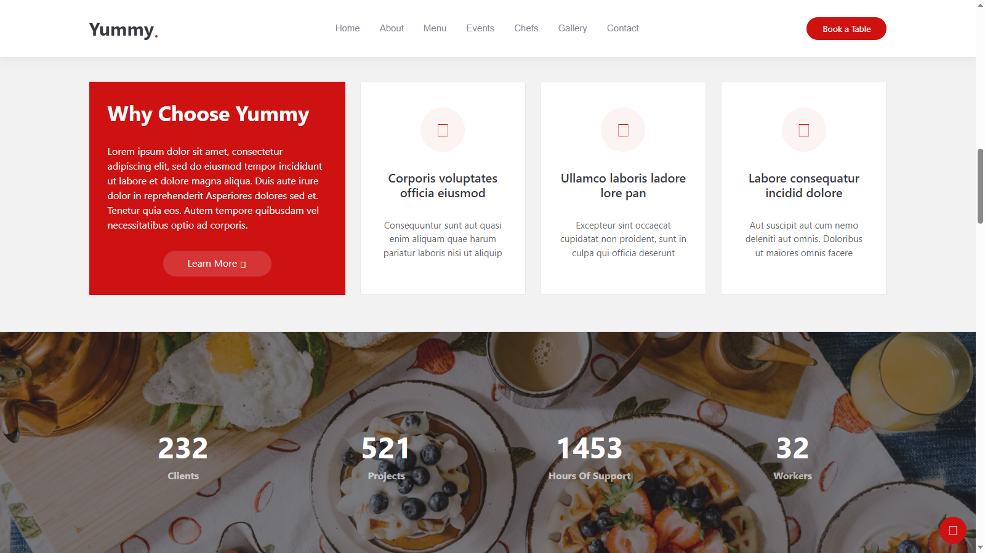

- Perform given Programs.

